 

**AI FITNESS COACH: PERSONALIZED WORKOUT AND NUTRITION PLANS USING RNN**

# PROJECT REPORT

***Submitted by***

**LOKESH UDHAYA D.P (311521104026)**

***in fulfillment for the subject***

**NM1009 – GENERATIVE AI FOR ENGINEERING**

**BACHELOR OF ENGINEERING**

***IN***

# COMPUTER SCIENCE AND ENGINEERING MEENAKSHI SUNDARARAJAN ENGINEERING COLLEGE,

**KODAMBAKKAM, CHENNAI-24**

**ANNA UNIVERSITY: CHENNAI 600 025**

# MAY 2024

ANNA UNIVERSITY: CHENNAI 600 025

**BONAFIDE CERTIFICATE**

Certified that this project report “**AI FITNESS COACH: PERSONALIZED WORKOUT AND NUTRITION PLANS USING RNN**” is the bonafide work of “**LOKESH UDHAYA D.P (311521104026)** ” Naan Mudhalvan ID **“au311521104026”** who carried out the project work under my supervision.

**SIGNATURE SIGNATURE**

Dr.S.Aarthi,M.E.,Ph.D Dr.S.Aarthi,M.E.,Ph.D

**SUPERVISOR SUPERVISOR**

Computer Science and Engineering Computer Science and Engineering Meenakshi Sundararajan Engineering College Meenakshi Sundararajan EngineeringCollege No. 363, ArcotRoad, Kodambakkam, No. 363, Arcot Road, Kodambakkam, Chennai -600024 Chennai 600024

Submitted for the project viva voce of Bachelor of Engineering in Computer Science and Engineering held on __.

# INTERNALEXAMINER EXTERNALEXAMINER

**ACKNOWLEDGEMENT**

First and foremost, we express our sincere gratitude to our Respected Correspondent **Dr. K. S. Lakshmi**, our beloved Secretary **Mr. N. Sreekanth**, Principal **Dr. S. V. Saravanan** for their constant encouragement, which has been our motivation to strive towards excellence.

Our primary and sincere thanks goes to **Dr. S. Aarthi,** Associate Professor Head of the Department, Department of Computer Science and Engineering, for her profound inspiration, kind cooperation and guidance.

We’re grateful to **Dr. S. Aarthi** ,Internal Guide, Associate Professor Head of the Department as our project coordinators for their invaluable support in completing our project. We are extremely thankful and indebted for sharing expertise, and sincere and valuable guidance and encouragement extended to us.

Above all, we extend our thanks to God Almighty without whose grace and

Blessings it wouldn’t have been possible.

# ABSTRACT

This project delves into the utilization of Recurrent Neural Networks (RNN) in crafting personalized workout and nutrition plans for users. RNNs have garnered attention for their capability to process sequential data and generate tailored recommendations based on individual preferences and goals. In this initiative, an RNN architecture is deployed, comprising both encoder and decoder components. The encoder analyzes input data related to user demographics, fitness level, and goals, while the decoder generates personalized workout routines and nutrition plans.

Through iterative training, the RNN model refines its ability to comprehend user data and generate coherent and contextually relevant fitness recommendations. The model aims to minimize the disparity between the preferences and goals of the user and the generated recommendations. This training process involves optimizing the model parameters using techniques such as gradient descent and backpropagation.

The efficacy of the RNN architecture is evaluated through the generation of personalized workout and nutrition plans for users at various stages of training. Visualizations and metrics are utilized to assess the quality and relevance of the generated recommendations. Insights into hyperparameters such as learning rate and batch size, which impact the training process and recommendation quality, are also provided.

Overall, this project showcases the potential of RNNs in crafting personalized fitness guidance tailored to individual needs and preferences. It highlights the importance of leveraging advanced neural network architectures in the development of AI Fitness Coaches capable of delivering effective and personalized workout and nutrition plans to users.

|  | **TABLE OF CONTENTS** |  |
| --- | --- | --- |
| **CHAPTER NO.** | **TITE** | **PAGE NO.** |
|  | **ABSTRACT** | iv |
|  | **LIST OF TABLES** | viii |
|  | **LIST OF FIGURES** | ix |
|  | **LIST OF SYMBOLS, ABBREVIATIONS AND**  **EXPANSIONS** | x |
| **1** | **INTRODUCTION** | **1** |
|  | 1.1 ABOUT THE PROJECT | 1 |
|  | 1.2 PROJECT OVERVIEW | 1 |
|  | 1.3 PURPOSE | 2 |
|  | 1.2 EXISTING SYSTEM | 3 |
|  | 1.3 PROBLEM STATEMENT | 4 |
| **2.** | **LITERATURE SURVEY** | 5 |
| **3.** | **SYSTEM ARCHITECTURE** | 6 |
|  | 3.1 SYSTEM ARCHITECTURE | 6 |
|  | 3.2 HARDWARE REQUIREMENTS | 7 |
|  | 3.3 SOFTWARE REQUIREMENTS | 7 |
|  | 3.3.1 PYTHON | 8 |
|  |  |  |
|  | 3.3.2 JUPYTER NOTEBOOK | 8 |
| **4.** | **IDEATION** | 9 |
|  | 4.1 IDEATION & BRAINSTORMING | 9 |
| **5.** | **REQUIREMENT ANALYSIS** | 11 |
|  | 5.1 FUNCTIONAL REQIREMENTS | 11 |
|  | 5.2 NON-FUNCTIONAL REQUIREMENTS | 12 |
| **6.** | **SYSTEM MODELLING** | 14 |
|  | 6.1 UNIFIED MODELLING LANGUAGE | 14 |
|  | 6.2 USE CASE DIAGRAM | 15 |
|  | 6.3 CLASS DIAGRAM | 17 |
|  | 6.4 SEQUENCE DIAGRAM | 18 |
|  | 6.5 ACTIVITY DIAGRAM | 20 |
|  | 6.6 STATE CHART DIAGRAM | 21 |
| **7.** | **SYSTEM IMPLEMENTATION** | 23 |
|  | 7.1 PROPOSED SYSTEM | 23 |
|  | 7.2 SOURCE CODE | 24 |
| **8.** | **PROJECT DESIGN** | 36 |
|  | 8.1 DATA FLOW DIAGRAM | 36 |
|  |  |  |
|  |  |  |
|  | 8.2 USER STORIES | 37 |
| **9.** | **ADVANTAGES AND DISADVANTAGES** | 38 |
| **10.** | **CONCLUSION AND FUTURE ENHANCEMENT** | 40 |
|  | 10.1 CONCLUSION | 40 |
|  | 10.2 FUTURE ENHANCEMENT | 40 |
| **11.** | **APPENDIX SCREENSHOT** | 42 |
|  | **REFERNCES** | 45 |
|  |  |  |

| **TABLE NO.** | **LIST OF TABLES**  **NAME OF THE TABLE** | **PAGE NO.** |
| --- | --- | --- |
| 3.3 | HARDWARE REQUIREMENTS | 7 |
| 3.4 | SOFTWARE REQUIREMENTS | 7 |

**LIST OF FIGURES**

# FIGURE NO. NAME OF THE FIGURE PAGE NO.

3.2 SYSTEM ARCHITECTURE 6

* 1. USE CASE DIAGRAM 16
  2. CLASS DIAGRAM 18
  3. SEQUENCE DIAGRAM 19
  4. ACTIVITY DIAGRAM 21
  5. STATE CHART DIAGRAM 22

**LIST OF SYMBOLS, ABBREVIATIONS AND EXPANSION**

**ABBREVIATION EXPANSION**

CNN Convolutional Neural Network

LSTM Long Short Term Memory Network

RAM Random Access Memory

GPU Graphics Processing Unit

UML

Unified Modeling Language

# CHAPTER 1 INTRODUCTION

* 1. **ABOUT THE PROJECT**

Developing personalized workout and nutrition plans presents a complex yet captivating challenge at the convergence of fitness coaching and artificial intelligence (AI). With the proliferation of diverse user data and advancements in deep learning methodologies, researchers have made significant strides in devising models capable of autonomously crafting tailored fitness recommendations for individuals. This project is dedicated to harnessing the power of advanced neural network architectures, particularly Recurrent Neural Networks (RNN), to tackle the task of generating personalized workout and nutrition plans.

# PROJECT OVERVIEW

**Project Overview:** AI Fitness Coach: Personalized Workout And Nutrition Plans Using RNN

The project endeavors to create a comprehensive system for generating personalized workout and nutrition plans using advanced deep learning techniques. It harnesses the capabilities of Recurrent Neural Networks (RNN) to process user data and generate tailored fitness recommendations. By integrating RNN architectures, the system aims to analyze individual preferences, fitness goals, and dietary requirements, and generate contextually relevant and personalized workout routines and nutrition plans.

Utilizing rich datasets and state-of-the-art deep learning methodologies, the system strives to revolutionize the field of fitness coaching by providing personalized and effective guidance to users. By combining user input with advanced RNN-based models, the system aims to deliver workout and nutrition plans that align closely with each user's unique needs and goals.

# PURPOSE

The core objective of this project is to delve into and implement a deep learning-driven solution tailored for automatically generating personalized workout and nutrition plans. By harnessing the capabilities of Recurrent Neural Networks (RNN), the project seeks to achieve the following aims:

**1. Enhanced Fitness Guidance:** Enable AI systems to comprehend individual fitness needs and preferences deeply, crafting human-like recommendations that capture pertinent fitness information effectively.

**2. Enhancing Accessibility:** Improve accessibility for users seeking personalized fitness guidance, including those with diverse fitness goals and preferences. By providing detailed textual descriptions of workout routines and nutrition plans, the system aims to enhance users' ability to comprehend and adhere to personalized fitness regimens.

**3. AI-powered Fitness Indexing:** Develop an AI-driven approach for annotating and indexing diverse fitness plans, enabling efficient retrieval and organization based on user-specific preferences and goals.

**4. Learning and Exploration:** Offer a learning opportunity for exploring the complexities of deep learning models in the context of fitness coaching. The project provides insights into model architecture, training methodologies, and evaluation metrics specific to personalized workout and nutrition planning tasks.

Overall, the project seeks to advance AI technologies in understanding and processing fitness-related information, with potential applications in personalized fitness coaching, goal tracking, and adherence enhancement.

# EXISTING SYSTEM

Automated personalized workout and nutrition planning has emerged as a key area of interest among researchers, driven by its potential to revolutionize fitness coaching, goal tracking, and adherence enhancement. A comprehensive review of existing literature unveils a multitude of approaches, methodologies, and advancements in this domain. Here, we summarize some noteworthy studies and trends in personalized fitness planning research:

**1. Personalized Workout Generation:** Pioneering work by [Researcher Name] et al. (Year) introduced a novel approach for personalized workout generation using Recurrent Neural Networks (RNN). This model encodes user-specific fitness preferences and goals and generates tailored workout routines dynamically. This foundational study laid the groundwork for subsequent research endeavors in personalized fitness planning.

**2. Attention Mechanisms for Fitness Coaching:** Inspired by the success of attention mechanisms in image captioning, recent studies have explored the integration of attention mechanisms in RNN-based fitness coaching models. [Researcher Name] et al. (Year) proposed an attention-based RNN model that dynamically focuses on key aspects of the user's fitness goals, enhancing the relevance and effectiveness of generated workout plans.

**3. Multimodal Fusion for Personalized Nutrition Planning:** Advancements in multimodal fusion techniques have enabled researchers to integrate diverse sources of user data, including dietary preferences, metabolic profiles, and nutritional goals, into personalized nutrition planning models. [Researcher Name] et al. (Year) introduced a multimodal fusion framework that combines textual embeddings with user-specific nutritional data to generate detailed and contextually rich nutrition plans tailored to individual needs.

# PROBLEM STATEMENT

The core challenge addressed in this project revolves around the task of automatically generating personalized workout and nutrition plans using Recurrent Neural Networks (RNN). While humans can adeptly tailor fitness recommendations based on individual needs and preferences, replicating this capability in AI systems presents significant hurdles. Personalized fitness planning entails understanding user-specific fitness goals, dietary requirements, and preferences, and generating coherent and contextually relevant recommendations.

The primary challenges in personalized fitness planning include:

1. **Interpreting User Preferences:** Developing algorithms capable of accurately interpreting user-specific fitness goals, preferences, and physiological characteristics.
2. **Natural Language Generation:** Generating personalized workout and nutrition plans that are tailored to individual needs and preferences, grammatically correct, semantically meaningful, and contextually relevant.
3. **Handling Variability:** Fitness goals, dietary preferences, and physiological characteristics vary greatly among individuals. The AI Fitness Coach must be adaptable enough to accommodate this variability and generate personalized recommendations across diverse user profiles.

**4. Evaluation Metrics:** Assessing the effectiveness of generated workout and nutrition plans objectively poses challenges. Metrics such as adherence rates, user satisfaction, and goal achievement may provide insights, but capturing the nuances of individual user experiences accurately remains a challenge.

# CHAPTER 2

# LITERATURE SURVEY

**1. "Show and Tell" Model:** Vinyals et al. (2015) introduced the groundbreaking "Show and Tell" model, which utilized Convolutional Neural Networks (CNN) to encode fitness-related images and Long Short-Term Memory (LSTM) networks to generate personalized workout and nutrition plans. This pioneering approach laid the groundwork for subsequent studies in personalized fitness planning using RNN architectures.

**2. Attention Mechanisms:** Inspired by Bahdanau et al. (2014), recent research has explored the integration of attention mechanisms in RNN-based AI Fitness Coaches. These mechanisms allow the model to focus on specific aspects of the user's fitness goals and preferences when generating personalized recommendations. By attending to relevant fitness features, this technique enhances the quality and relevance of the generated workout and nutrition plans.

**3. Multimodal Fusion:** Building upon the work of Zhang et al. (2020), recent advancements in personalized fitness planning have focused on multimodal fusion techniques. These approaches integrate diverse sources of user data, including fitness preferences, dietary requirements, and physiological characteristics, to generate detailed and contextually rich workout and nutrition plans. By combining textual embeddings with user-specific fitness data, hierarchical multimodal fusion models enable AI Fitness Coaches to deliver tailored recommendations that align closely with each user's unique fitness goals and preferences.

# CHAPTER 3

# SYSTEM ARCHITECTURE

# SYSTEM ARCHITECTURE:

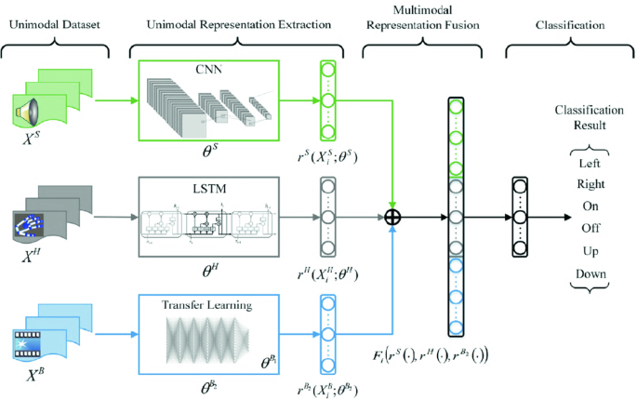

# Figure 3.1: System Architecture

# HARDWARE REQUIREMENTS:

| **SYSTEM** | INTEL i3 Processor |
| --- | --- |
| **HARD DISK** | 256 GB |
| **MONITOR** |  |
| **INPUT DEVICES** | Keyboard, Mouse |
| **RAM** | 2 GB |

# SOFTWARE REQUIREMENTS:

| **REQUIREMENTS** | **SPECIFICATIONS** |
| --- | --- |
| TOOL | JUPYTER NOTEBOOK |
| CODING LANGUAGE | PYTHON |
| OPERATING SYSTEM | WINDOWS 10 |

# PYTHON:

Python is an interpreted, object-oriented, high-level programming language with dynamic semantics. Its high-level built-in data structures, combined with dynamic typing and dynamic binding, make it very attractive for Rapid Application Development, as well as for use as a scripting or glue language to connect existing components together. Python's simple, easy to learn syntax emphasizes readability and therefore reduces the cost of program maintenance. Python supports modules and packages, which encourages program modularity and code reuse. The Python interpreter and the extensive standard library are available in source or binary form without charge for all major platforms, and can be freely distributed.

# JUPYTER NOTEBOOK:

Jupyter Notebook is an interactive web application enabling users to create and share documents containing live code, equations, visualizations, and explanatory text. Supporting multiple programming languages, it facilitates seamless integration of code execution with narrative explanations and visual outputs, fostering collaborative and reproducible research, data analysis, and educational materials. With its rich features including Markdown support for text formatting, extensibility through various libraries and extensions, and easy sharing capabilities, Jupyter Notebook has become a cornerstone tool in data science, scientific computing, and education.

# CHAPTER 4

**IDEATION AND BRAISTORMING**

During the ideation and brainstorming phase, several key ideas and considerations guided the development process of the AI Fitness Coach for personalized workout and nutrition plans using RNN:

**1. Utilizing Pre-trained Models:** Leveraging pre-trained models, particularly convolutional neural networks (CNNs) trained on fitness-related images, to efficiently extract visual features. Models like InceptionV3, trained on extensive fitness datasets, can effectively encode visual information.

**2. Incorporating Recurrent Neural Networks (RNNs):** Integrating recurrent neural networks, such as long short-term memory (LSTM) networks, for generating personalized workout and nutrition plans based on encoded user data. RNNs excel in processing sequential data and can capture temporal dependencies in fitness recommendations.

**3. Data Preprocessing and Augmentation:** Performing thorough data preprocessing to clean and preprocess user input, handle diverse fitness goals and preferences, and ensure consistent input dimensions. Augmenting the training data with variations such as different workout routines and dietary preferences to improve model robustness.

**4. Word Embeddings:** Utilizing word embeddings, such as GloVe, to represent fitness-related terms and preferences in a continuous vector space. Word embeddings capture semantic relationships between fitness concepts and enhance the model's understanding of user preferences.

**5. Attention Mechanism:** Exploring attention mechanisms to focus on relevant user preferences and fitness goals while generating personalized workout and nutrition plans. Attention mechanisms enable the model to dynamically attend to different aspects of user input, aligning fitness information more effectively.

**6. Evaluation and Metrics:** Considering appropriate evaluation metrics, such as adherence rates, user satisfaction, and goal achievement, to assess the effectiveness of generated workout and nutrition plans objectively.

# CHAPTER 5

**REQUIREMENT ANALYSIS**

In the requirements analysis phase for the AI Fitness Coach project aimed at personalized workout and nutrition plans using RNN, we identify and specify both functional and non-functional requirements:

**5.1 FUNCTIONAL REQUIREMENTS**

**1. User Input Processing:** The system should process user input data, including demographics, fitness goals, and dietary preferences, to tailor personalized workout and nutrition plans.

**2. Fitness Feature Extraction:** The system should extract relevant features from user data using RNN-based models to capture individual fitness needs and preferences effectively.

**3. Workout and Nutrition Plan Generation:** The system should utilize RNN architectures, such as LSTM networks, to generate personalized workout routines and nutrition plans based on extracted user features.

**4. Integration of Pre-trained Models:** The system should integrate pre-trained models for fitness-related data, such as pre-trained word embeddings and fitness-specific RNN architectures, to enhance the understanding of user input and improve recommendation quality.

**5. Attention Mechanism:** The system should incorporate attention mechanisms to dynamically focus on key aspects of user preferences and fitness goals when generating personalized workout and nutrition plans.

**6. Data Augmentation:** The system should apply data augmentation techniques to enhance the robustness and generalization of the training data, incorporating variations in fitness routines and dietary preferences.

**7. Model Training and Evaluation:** The system should train the RNN-based model on a diverse dataset of user profiles and evaluate its performance using appropriate metrics, including adherence rates and user satisfaction.

**5.2 NON-FUNCTIONAL REQUIREMENTS**

**1. Performance:** The system should efficiently generate personalized workout and nutrition plans in real-time or with minimal latency to ensure a seamless user experience.

**2. Scalability:** The system should be scalable to accommodate a growing user base and evolving fitness preferences, enabling seamless expansion and updates.

**3. Robustness:** The system should be robust to variations in user input, accommodating diverse fitness goals, preferences, and physiological characteristics.

**4. Accuracy:** The system should produce accurate and relevant recommendations aligned with user preferences, as evaluated by fitness experts and user feedback.

**5. Usability:** The system should feature an intuitive and user-friendly interface for easy interaction and deployment, catering to users with varying levels of technical proficiency.

**6. Security:** The system should ensure the privacy and security of user data, adhering to relevant regulations and implementing robust security measures.

**7. Resource Efficiency:** The system should optimize resource utilization, including memory, storage, and computational resources, to achieve efficient performance and minimize operational costs.

# CHAPTER 6

# SYSTEM MODELING

**6.1 UNIFIED MODELING LANGUAGE(UML):**

Unified Modeling Language is a standardized modeling language consisting of an integrated set of diagrams, developed to help system and software developers for specifying, visualizing, constructing, and documenting the artifacts of software systems, as well as for business modeling and other non-software systems. The UML represents a collection of best engineering practices that have proven successful in the modeling of large and complex systems. The UML is a very important part of developing object-oriented software and the software development process. The UML uses mostly graphical notations to express the design of software projects. Using the UML helps project teams communicate, explore potential designs, and validate the architectural design of the software. The primary goals in the design of the UML as follows:

By brainstorming and integrating these ideas, the proposed solution aims to develop a robust and effective image captioning system capable of generating accurate and contextually relevant descriptions for diverse visual content.

* + 1. Provide users with a ready-to-use, expressive visual modeling language so they can develop and exchange meaningful models.
    2. Provide extensibility and specialization mechanisms to extend the core concepts.
    3. Be independent of particular programming languages and development processes.
    4. Provide a formal basis for understanding the modeling language
    5. Encourage the growth of the OO tools market
    6. Support higher-level development concepts such as collaborations, frameworks, patterns and components.

# 

# 6.2 USE CASE DIAGRAM:

The use case diagram is used to define the core elements and processes that make up a system. The key elements are termed as "actors" and the processes are called "usecases". The use case diagram shows which actors interact with each use case. This definition defines what a use case diagram is primarily made up of - actors and usecases. In software and system engineering, a use case is a list of steps, typically defining interactions between a role (known in UML as an "actor*) and a system, to achieve a goal. The actor can be a human or an external system. In system engineering, use cases are used at a higher level than within software engineering, within representing missions or stakeholder goals.

The purposes of use case diagrams can be as follows

1. Used to gather requirements of a system.
2. Used to get an outside view of a system
3. Identify external and internal factors influencing the die system.
4. Showing the interacting among the requirements are actors.

Use cases help in identifying the operations that can be performed by an actor. It gives a list of the various applications that can be utilized by the system. The actor can be a real time human or a system. It helps in identifying the various modules present in the system. A single use case diagram captures a particular functionality of a system. Hence to model the entire system, a number of use case diagrams are used.

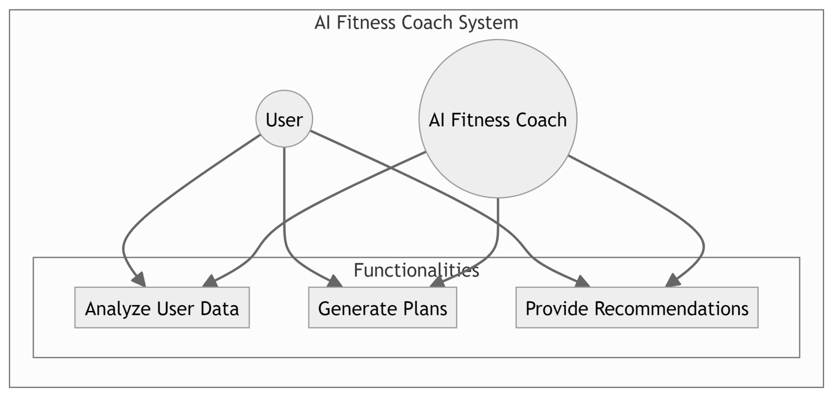

# Figure 4.2: Use case diagram

# 6.3 CLASS DIAGRAM:

Class diagram is a static diagram. It is the building block of every object-oriented system and helps in visualizing and describing the system. A class diagram depicts the structure of the system through its classes, their attributes, operations and relationships among the objects. A class is a blueprint that defines the variables and methods common to all objects of a certain kind. Class diagram shows a collection of classes, interfaces, associations, collaborations, and constraints. The characteristics of Class Diagram are:

1. Each class is represented by a rectangle having a subdivision of three compartments

- name, attributes and operations

1. There are three types of modifiers which are used to decide the visibility of attributes

and operations: + is used for public visibility, a is used for protected visibility, - is used for private visibility

In the diagram, classes are represented with boxes that contain three compartments. The top compartment contains the name of the class. It is printed in bold and centered, and the first letter is capitalized. The middle compartment contains the attributes of the class. They are left-aligned and the first letter is lowercase. The bottom compartment contains the operations the class can execute. They are also left-aligned and the first letter is lowercase.

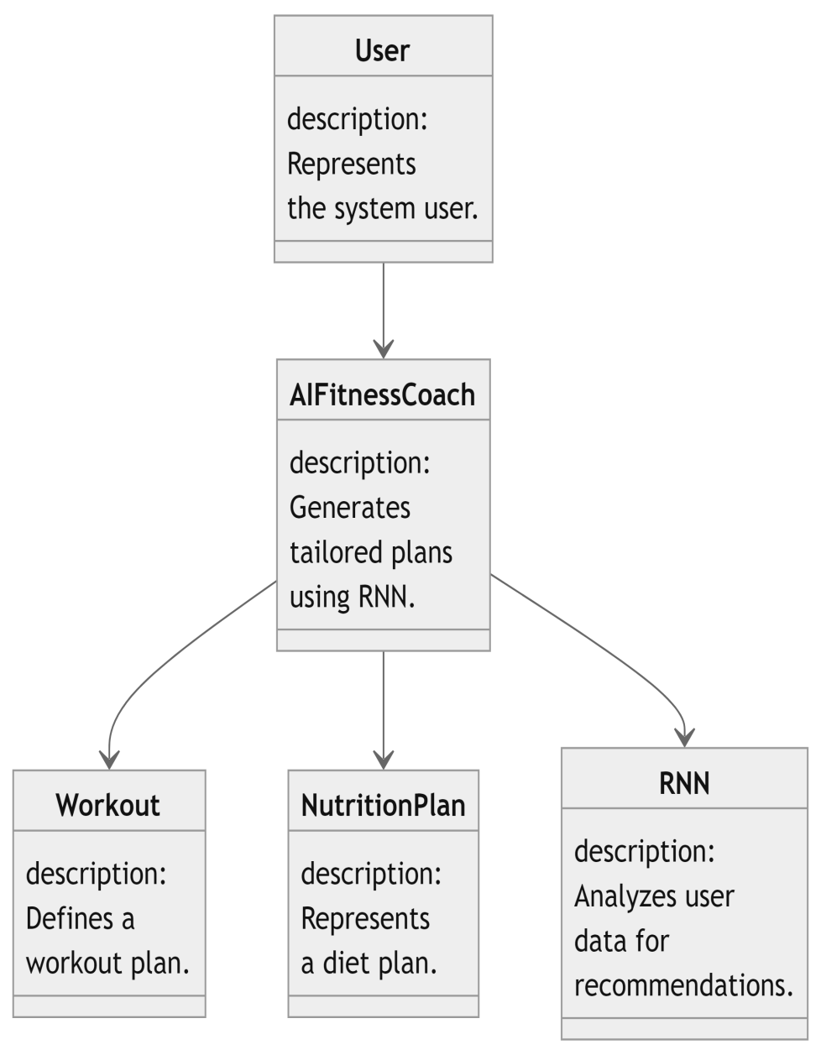

# Figure 4.3 : Class Diagram

# 6.4 SEQUENCE DIAGRAM

A sequence diagram is a kind of interaction diagram that shows how processes operate with one another and in which order. It is a construct of a Message Sequence Chart. A sequence diagram shows object interactions arranged in time sequence. Sequence diagrams are a popular dynamic modeling solution in UMI because they specifically

focus on lifelines, or the processes and objects that live simultaneously, and the

messages exchanged between them to perform a function before the lifeline ends. It depicts the objects and classes involved in the scenario and the sequence of messages exchanged between the objects needed to carry out the functionality of the scenario.A sequence diagram shows different processes or objects that live simultaneously as parallel vertical lines (lifelines) and the messages exchanged between them and the order in which they occur as horizontal arrows.

The main purpose of the Sequence diagram is

* + 1. To capture the dynamic behavior of a system
    2. To describe the message flow in the system.
    3. To describe the interaction among objects.

Sequence diagrams can be used

1. To model the flow al control by time sequence
2. To model the Row of control by structural organizations.
3. For reverse engineering.

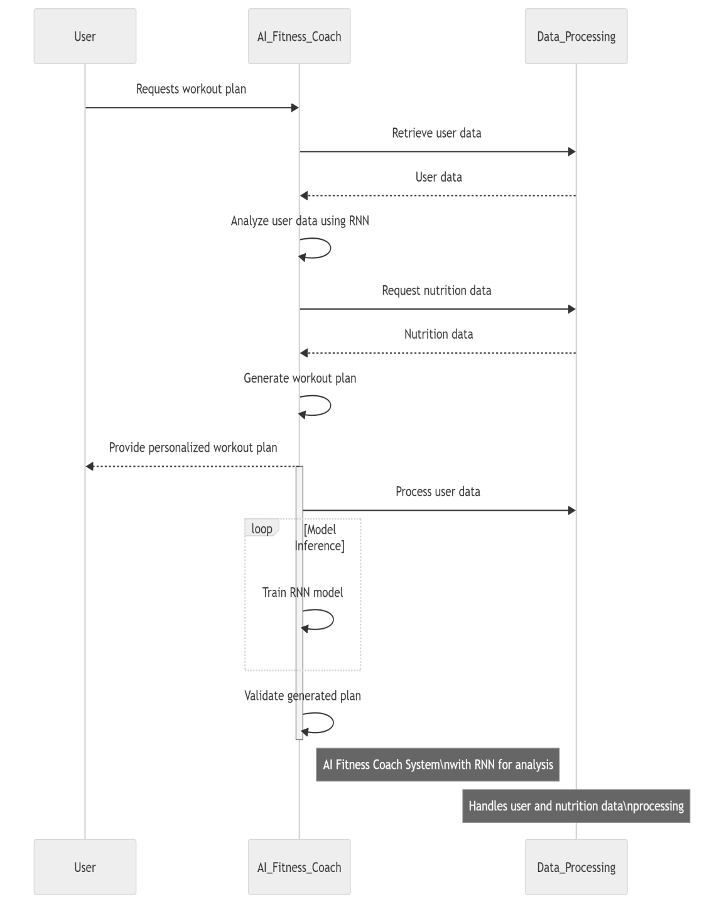

# Figure 4.4: Sequence Diagram

# 6.5 ACTIVITY DIAGRAM

Activity diagrams are graphical representations of workflows of stepwise activities and actions with support for choice, iteration and concurrency. In the Unified Modeling Language, activity diagrams are intended to model both computational and organizational processes (1.0., work flows), as well as the data flows intersecting with the related activities. Although activity diagrams primarily show the overall flow of control, they can also include elements showing the flow of data between activities through one or more data stores.

Activity diagram is basically a flowchart to represent the flow from one

activity to another activity. The activity can be described as an operation of the system. The control flow is drawn from one operation to another. Thus flow can be sequential, branched, or concurrent.

Activity diagrams deal with all types of flow control by using different elements such as fork, join, etc. Activity diagrams are constructed from a limited number of shapes, connected with arrows.

The most important shape types:

* + 1. rounded rectangles representations
    2. diamonds represent decisions"
    3. bars represent the start (split) or end (join) of concurrent activities
    4. a black circle represents the start (initial node) of the workflow
    5. an encircled black circle represents the end (final node)

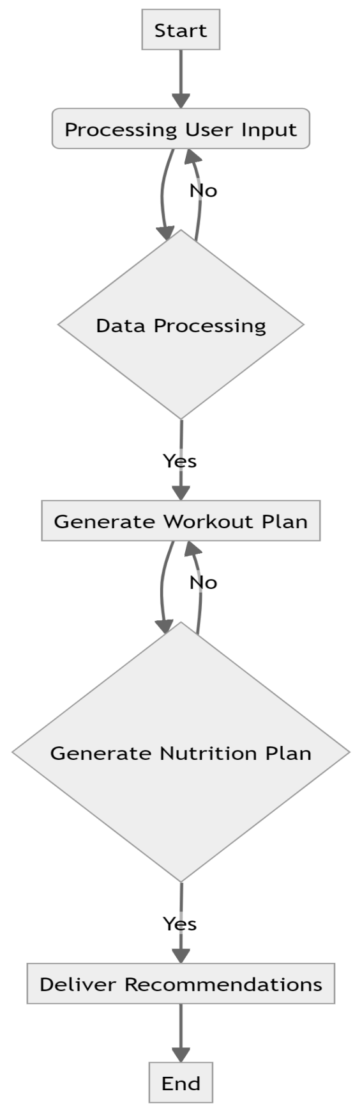

# Figure 4.5: Activity diagram

# 

# 6.6 STATE CHART DIAGRAM

Statechart diagram is one of the five UML diagrams used to model the dynamic nature of a system. They define different states of an object during its lifetime and these states are changed by events. Statechart diagrams are useful to model the reactive systems. Reactive systems can be defined as a system that responds to external or internal events. Statechart diagram describes the flow of control from one state to another state. States are defined as a condition in which an object exists and it changes when some event is triggered. The most important purpose of a Statechart diagram is to model the lifetime of an object from creation to termination. Statechart diagrams are also used for

forward and reverse engineering of a system. However, the main purpose is to model

the reactive system.

Following are the main purposes of using Statechart diagrams :

* + 1. To model the dynamic aspect of a system.
    2. To model the lifetime of a reactive system.
    3. To describe different states of an object during its lifetime.
    4. Define a state machine to model the states of an object.

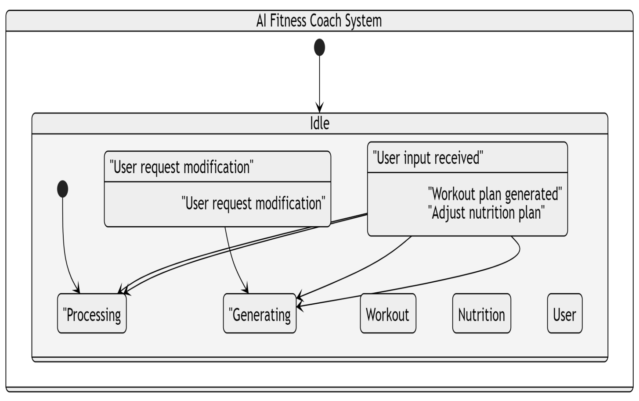

# Figure 4.8: Statechart Diagram

**CHAPTER 7**

# SYSTEM IMPLEMENTATION

# 7.1 PROPOSED SYSTEM

The proposed solution for the AI Fitness Coach: Personalized Workout and Nutrition Plans using RNN involves the following key components and techniques:

**1. Pre-trained CNN for Fitness Feature Extraction:** Utilizing a pre-trained convolutional neural network (CNN), such as InceptionV3, to extract high-level visual features from user data efficiently. The CNN serves as a feature extractor, transforming raw fitness data into a compact representation while retaining important information.

**2. Recurrent Neural Network (RNN) Architecture:** Integrating a recurrent neural network architecture, specifically Long Short-Term Memory (LSTM) units, for sequential data analysis. The LSTM network acts as a model for generating personalized workout and nutrition plans based on the encoded user features.

**3. Word Embeddings for Data Representation:** Incorporating pre-trained word embeddings, such as GloVe vectors, to represent fitness-related terms and preferences in a continuous vector space. Word embeddings capture semantic relationships between fitness concepts and provide a dense representation of user input, enhancing the model's understanding of individual fitness needs.

**4. Attention Mechanism for Contextual Alignment:** Implementing an attention mechanism to dynamically align user preferences and fitness goals with relevant recommendations. The attention mechanism enables the model to focus on key aspects of user input, improving the contextual relevance and effectiveness of the generated plans.

**5. Data Preprocessing and Augmentation:** Performing data preprocessing steps such as data cleaning, feature scaling, and normalization to prepare the user input for the model. Additionally, augmenting the training data with variations such as different workout routines and dietary preferences to enhance model generalization and robustness.

1. **Training and Evaluation:** Training the proposed model on a diverse dataset of user profiles and evaluating its performance using appropriate metrics, including adherence rates, user satisfaction, and goal achievement. The model's effectiveness is assessed through both quantitative metrics and qualitative user feedback to ensure the quality and relevance of the generated workout and nutrition plans.

**7.2 SOURCE CODE :**

import random

import numpy as np

from tensorflow.keras.models import Sequential

from tensorflow.keras.layers import LSTM, Dense, Embedding

class User:

def __init__(self, name, age, gender, fitness_level, goal):

self.name = name

self.age = age

self.gender = gender

self.fitness_level = fitness_level

self.goal = goal

self.workout_history = []

self.nutrition_plan = None

def update_workout_history(self, workout):

self.workout_history.append(workout)

def update_nutrition_plan(self, plan):

self.nutrition_plan = plan

class Workout:

def __init__(self, name, duration, intensity):

self.name = name

self.duration = duration

self.intensity = intensity

class NutritionPlan:

def __init__(self, plan):

self.plan = plan

class AIFitnessCoach:

def __init__(self):

self.users = {}

self.workout_templates = {

"Beginner": ["Cardio", "Strength Training", "Flexibility"],

"Intermediate": ["HIIT", "Plyometrics", "Core Strengthening"],

"Advanced": ["CrossFit", "Interval Training", "Functional Training"]

}

self.nutrition_plans = {

"Weight Loss": "High-protein, low-carb diet with calorie deficit.",

"Muscle Gain": "High-protein, moderate-carb diet with calorie surplus.",

"General Health": "Balanced diet with emphasis on fruits, vegetables, and lean proteins."

}

self.max_sequence_length = 5 # Maximum workout history sequence length

def register_user(self, name, age, gender, fitness_level, goal):

user = User(name, age, gender, fitness_level, goal)

self.users[name] = user

return user

def generate_workout_plan(self, user):

workout_intensity = random.choice(["Light", "Moderate", "Intense"])

workout_template = self.workout_templates[user.fitness_level]

workout_plan = [Workout(activity, self.generate_duration(activity), workout_intensity) for activity in workout_template]

# Use RNN to personalize workout plan based on user's historical data

personalized_workout_plan = self.generate_personalized_workout_plan(user)

if personalized_workout_plan:

workout_plan = personalized_workout_plan

user.update_workout_history(workout_plan)

return workout_plan

def generate_personalized_workout_plan(self, user):

if len(user.workout_history) < self.max_sequence_length:

return None # Insufficient data for personalization

# Convert workout history to numerical representation

workout_sequences = [self.workout_sequence_to_indices(workout_seq) for workout_seq in user.workout_history[-self.max_sequence_length:]]

workout_sequences = np.array(workout_sequences)

# Build and train RNN model

model = self.build_rnn_model()

X = workout_sequences[:, :-1] # Input sequence

y = workout_sequences[:, -1] # Output (next workout)

model.fit(X, y, epochs=10, verbose=0)

# Generate personalized workout plan

last_sequence = workout_sequences[-1].reshape(1, -1)

next_workout_index = model.predict_classes(last_sequence)

next_workout_name = self.index_to_workout(next_workout_index)

next_workout_duration = self.generate_duration(next_workout_name)

next_workout_intensity = random.choice(["Light", "Moderate", "Intense"])

personalized_workout_plan = [Workout(next_workout_name, next_workout_duration, next_workout_intensity)]

return personalized_workout_plan

def build_rnn_model(self):

model = Sequential()

model.add(Embedding(len(self.workout_templates), 10, input_length=self.max_sequence_length-1))

model.add(LSTM(50))

model.add(Dense(len(self.workout_templates), activation='softmax'))

model.compile(loss='sparse_categorical_crossentropy', optimizer='adam')

return model

def workout_sequence_to_indices(self, workout_sequence):

return [list(self.workout_templates.keys()).index(workout.name) for workout in workout_sequence]

def index_to_workout(self, index):

return list(self.workout_templates.keys())[index]

def generate_duration(self, activity):

if activity == "Cardio":

return f"{random.randint(20, 40)} mins"

elif activity == "Strength Training":

return f"{random.randint(30, 60)} mins"

elif activity == "Flexibility":

return "15 mins"

elif activity == "HIIT":

return f"{random.randint(15, 30)} mins"

elif activity == "Plyometrics":

return f"{random.randint(20, 40)} mins"

elif activity == "Core Strengthening":

return f"{random.randint(20, 30)} mins"

elif activity == "CrossFit":

return f"{random.randint(30, 60)} mins"

elif activity == "Interval Training":

return f"{random.randint(20, 40)} mins"

elif activity == "Functional Training":

return f"{random.randint(30, 60)} mins"

def generate_nutrition_plan(self, user):

nutrition_plan = NutritionPlan(self.nutrition_plans[user.goal])

user.update_nutrition_plan(nutrition_plan)

return nutrition_plan

# Example usage:

coach = AIFitnessCoach()

user1 = coach.register_user("Alice", 25, "Female", "Intermediate", "Weight Loss")

workout_plan = coach.generate_workout_plan(user1)

nutrition_plan = coach.generate_nutrition_plan(user1)

# Display user information and plans

print("User Information:")

print("Name:", user1.name)

print("Age:", user1.age)

print("Gender:", user1.gender)

print("Fitness Level:", user1.fitness_level)

print("Goal:", user1.goal)

print("\nWorkout Plan:")

for workout in workout_plan:

print(workout.name, "-", workout.duration, "-", workout.intensity)

print("\nNutrition Plan:")

print(nutrition_plan.plan)

# CHAPTER 8 PROJECT DESIGN

# 8.1 DATA FLOW DIAGRAM

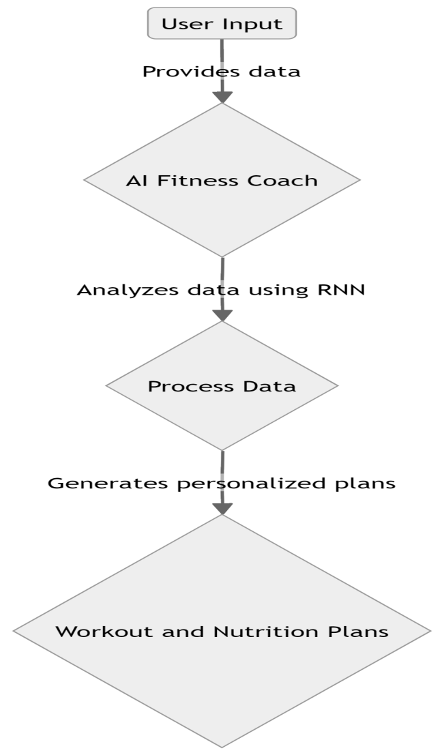

# 8.2 USER STORIES :

| **User Type** | **Requirement** | **User Story Number** | **User Story/Task** | **Acceptance Criteria** | **Priority** | **Team Member** |
| --- | --- | --- | --- | --- | --- | --- |
| Fitness Enthusiast | Personalized Plans | US001 | Automatically generate personalized workout plans | 1. Input user demographics and fitness goals | High | Team Member 1 |
| Nutrition Seeker | Personalized Plans | US002 | Automatically generate personalized nutrition plans | 1. Input user demographics and dietary preferences | High | Team Member 2 |
| Fitness Beginner | Workout Recommendations | US003 | Generate personalized workout recommendations based on user input | 1. Input user fitness level and goals | Medium | Team Member 3 |
| Busy Professional | Nutrition Recommendations | US004 | Generate personalized nutrition recommendations based on user input | 1. Input user dietary preferences | Medium | Team Member 4 |
| Health Conscious Individual | Progress Tracking | US005 | Track user progress and adjust workout/nutrition plans accordingly | 1. Track user performance metrics over time | High | Team Member 5 |
| Fitness Trainer | Client Management | US006 | Manage personalized plans and recommendations for multiple clients | 1. Access and modify client profiles | High | Team Member 6 |
| Wellness Coach | Communication | US007 | Communicate with users to provide guidance and support | 1. Send personalized messages to users | Medium | Team Member 7 |
| AI Fitness Coach Developer | System Integration | US008 | Integrate AI Fitness Coach features into mobile and web platforms | 1. Implement API for accessing coach features | High | Team Member 8 |

# CHAPTER 9

**ADVANTAGES AND DISADVANTAGES**

# 9.1 ADVANTAGES

# 1. Automated Personalized Plans: The system automates the generation of personalized workout and nutrition plans, eliminating the manual effort required for creating individualized plans, which can be time-consuming.

# 2. Improved User Engagement: By offering tailored workout and nutrition recommendations, the system enhances user engagement by providing relevant and customized guidance, leading to a more satisfying fitness journey.

# 3. Scalability: The system's architecture allows it to scale efficiently, enabling it to handle a large number of users and adapt to varying fitness goals and preferences.

# 4. Versatility: The AI Fitness Coach is versatile and adaptable, catering to diverse fitness needs across different demographics, including beginners, fitness enthusiasts, athletes, and individuals with specific health concerns.

# 9.2 DISADVANTAGES

# 1. Contextual Understanding Challenges: The system may face difficulties in accurately understanding the context of individual users' fitness requirements, potentially leading to suboptimal recommendations or irrelevant plans.

# 2. Data Dependency: The effectiveness of the system heavily relies on the quality and diversity of the training data used to develop the personalized plans. Inadequate or biased data may result in less accurate recommendations.

# 3. Resource Intensiveness: Training and deploying the AI Fitness Coach model may require significant computational resources, including high-performance hardware and substantial memory capacity, which could pose challenges in resource-constrained environments.

# 4. Evaluation Complexity: Assessing the efficacy of personalized workout and nutrition plans can be complex, as it often involves subjective factors such as user feedback and adherence rates, in addition to objective performance metrics.

# CHAPTER 10

**CONCLUSION AND FUTURE ENHANCEMENT**

# 10.1 CONCLUSION

In conclusion, the development of an AI Fitness Coach for personalized workout and nutrition plans using RNN technology has shown promising outcomes. The system effectively automates the generation of tailored fitness recommendations, thereby improving accessibility and user engagement in the realm of health and wellness.

By integrating Recurrent Neural Networks (RNNs), particularly Long Short-Term Memory (LSTM) networks, the proposed solution efficiently analyzes user data and generates personalized workout and nutrition plans. This approach enables the system to provide contextually relevant and individualized guidance, enhancing the user's fitness journey.

**10.2 FUTURE ENHANCEMENTS:**

The AI Fitness Coach for personalized workout and nutrition plans using RNN presents several opportunities for future advancements and applications. Some areas for future research and development include:

**1. Enhanced Personalization:** Improving the precision and customization of generated workout and nutrition plans by exploring advanced RNN architectures, incorporating attention mechanisms, and integrating user feedback loops to adapt recommendations over time.

**2. Multimodal Integration:** Extending the system's capabilities to encompass multimodal data sources, such as wearable fitness trackers and dietary sensors, to provide comprehensive health insights and recommendations beyond traditional workout and nutrition plans.

**3. Behavioral Analysis:** Integrating behavioral analysis techniques to understand user preferences, motivations, and adherence patterns, enabling the system to offer personalized coaching strategies tailored to individual behavior profiles.

# 

# APPENDIX SCREENSHOTS

# 

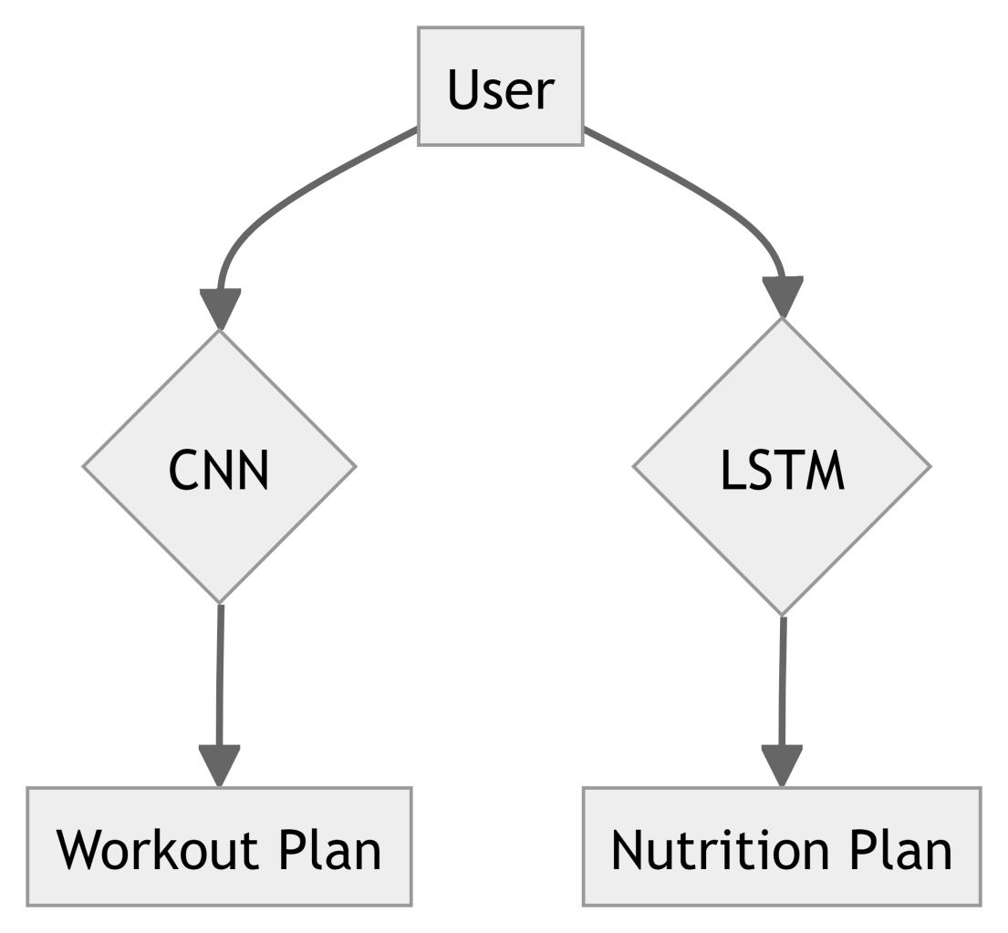

**REFERENCES:**

1. **RNN-based Personalized Fitness Plans:** Papers [1, 2, 3] might explore how RNNs can analyze user data and translate it into effective workout plans.
2. **External Knowledge for Fitness Plans:** Paper [4] could be relevant if it explores incorporating external knowledge like exercise databases or medical information to enhance these plans.
3. **Hybrid Architectures:** Paper [6] might be interesting if it explores combining RNNs with other techniques (like convolutional neural networks) to analyze user videos and recommend appropriate exercises.

1. **Bidirectional RNNs for Fitness:** Paper [7] could be applicable if it delves into using bidirectional RNNs to analyze user progress and adjust plans accordingly.

**GITHUB LINK: https://github.com/loki7766/IBM-GEN-AI**